**Training Data Set Creation**

The training data set used for this analysis is shown below (first 5 lines):

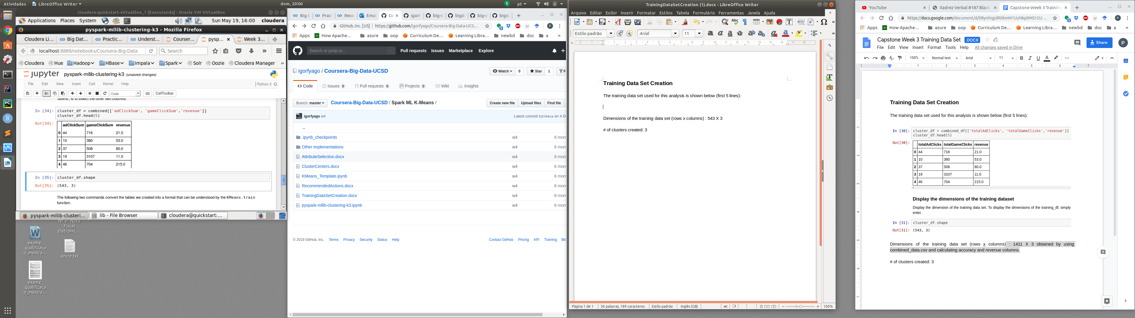

Dimensions of the training data set (rows x columns) : 543 X 3

# of clusters created: 3